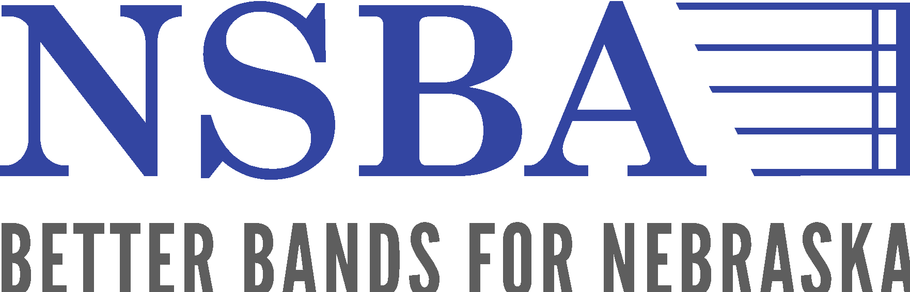

December 1st, 2021

Dear Colleagues,

My name is Tom Thorpe and I am honored to serve the Nebraska State Bandmasters Association as the organization’s current Concert Band Chair. I am excited to share materials regarding the 2022 NSBA Concert Band Festival with each of you.

The annual NSBA Concert Band Festival will take place on April 6th, 2022 at Kearney High School. This annual festival provides a non-competitive environment that serves all levels of ensembles in the state of Nebraska—middle school, high school, and college/university groups. In addition to having the opportunity to perform in this outstanding concert venue, students and directors will receive immediate and applicable feedback from some of the finest musicians and educators in the country—including a 30-minute private clinic with one of the 2022 Concert Band Festival clinicians (a truly unique and valuable aspect of the NSBA Concert Band Festival). At the conclusion of their ensemble’s performance, directors will receive professional audio recordings of their stage performance and a video recording of their ensemble’s clinic.

I hope that you will consider bringing your ensembles to this incredible event. It is a truly world-class opportunity for Nebraska students in service one of NSBA’s primary goals: creating “Better Bands For Nebraska.”

Festival Details

Date: April 6, 2022
Location: Kearney High School
How to Register: Visit www.NSBMA.org and click on the link that says “Concert” at the top of the page.
Entry Fee for Participating Groups: $175 (mailed separately – online payment not accepted at this time)

2022 Concert Band Festival Clinicians

Dr. Wesley Broadnax, University of Northern Colorado
Dr. Robert Belser, University of Wyoming
Dr. John Bell, Northwest Missouri State University

